GUAYAQUIL – GALAPAGOS

Itinerary 2009

Day 1: Tuesday 01.02
Guayaquil

Upon arrival to Guayaquil’s Jose Joaquin de Olmedo Airport, you will be greeted by our helpful guide. The guide will serve as a translator, help with luggage, and assist with the car transfer to your hotel.

Accomodation al Best Western Doral Hotel or similar.

Day 2-7: Wednesday 02.09-Monday 07.09
Guayaquil-Galapagos

Breakfast. Transfer to the airport, flight to Galapagos Island.
Transfer to your hotel.

6 days/5 nights at Silberstein Hotel with 3 days of diving.

Tour includes: Breakfast mini-buffet, accommodation at the hotel, transfers in Galapagos Islands, visit of the Charles Darwin Station, 2 dives per day, 3 days of diving with dive master, equipment included.

Depending on weather conditions or Galapagos National Park regulations you will dive in one of the following places each day: ACADEMIA BAY, FLOREANA, SANTA FE, GORDON ROCKS, SEYMUR, COUSIN, BARTOLOME, DAPHNE, MOSQUERA.

Day1
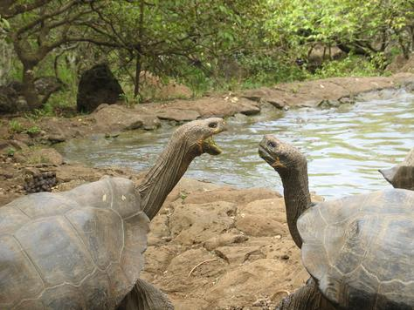
AM: Baltra airport, Galapagos
The flight from Guayaquil to the Galapagos is approximately 1 ½ hours on a Boeing 727. Upon arrival at Baltra travellers pass through an airport inspection point to insure that no foreign plants or animals are introduced to the islands and to pay the park entrance fee of $100 (unless prepaid). Guides will meet you, collect your luggage and escort you on the short bus ride to the harbor. Motorized rafts will transport you to the Santa Cruz Island where your first island visit is made.

PM: Santa Cruz Island - Charles Darwin Station
Although the great majority of Galapagos visitors come here to observe and appreciate natural wonders, it is also interesting to learn how the protection and conservation of the islands are carried out. One of the principal attractions are National Park information centre, Van Staelen Exhibition Hall, Breeding and Rearing Centre for young tortoises, Lonesome George (tortoise from Pinta), adult Galapagos tortoises in captivity.
Transfer to the hotel.
B.

Days 2-4
Depending on weather conditions or Galapagos National Park regulations you will dive in one of the following places each day: ACADEMIA BAY, FLOREANA, SANTA FE, GORDON ROCKS, SEYMUR, COUSIN, BARTOLOME, DAPHNE, MOSQUERA. 2 dives per day

ACADEMIA BAY
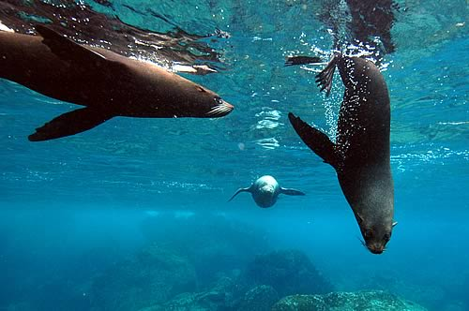
This is the bay of Puerto Ayora on Santa Cruz Island with 4 dive sites all within 20 minutes from our base by boat. Three of the sites are generally calm with little current; ideal for students or novices. At the other site, the dives can be a little more complicated if there is a current so they are suitable for intermediate or expert divers. Frolic with sea lions or listen as the damselfish munches away at its algae farm. You may also see marine iguanas, rays, and even sharks all just outside your hotel's door!

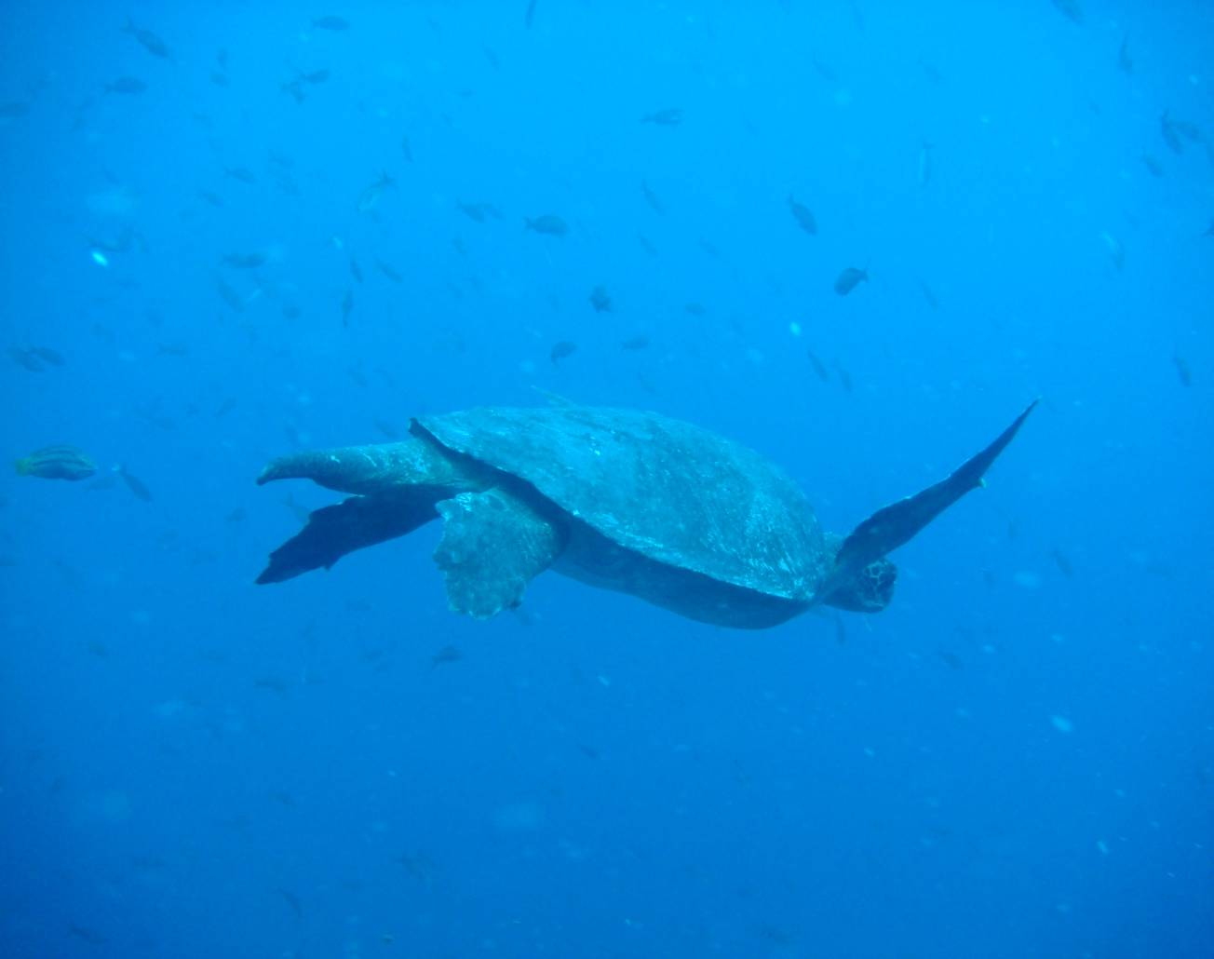
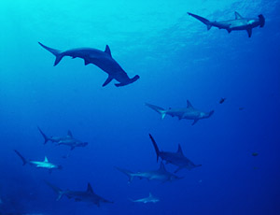
FLOREANA
The island of Floreana is about 90 minutes south from our dive base. There are 9 dive sites here with generally calm waters. On the occasion that we do find strong currents, we can quickly move to another site, which makes Floreana ideal for all levels of divers. This site is one of the best in the central islands to see significant coral colonies, such as pebble coral and endemic black coral. You might encounter baby birds as they make unsuccessful attempts learning to fly. You may look on as barber fish clean sea turtles of parasites. Floreana is also one of the best sites to dive with sea lions. If that isn't enough there is the enticing gauntlet of sea horses, stingrays, eagle rays, turtles, long nose hawk fish, barracudas, pelagic fish, white tip reef sharks, Galapagos sharks, and hammerhead sharks.

SANTA FE
This island is a solid structure of basaltic lava rocks about an hour away from our base. The 4 dive sites here generally have excellent visibility and mild currents, making these sites ideal for novices. At the same time, the animals and topography (including a spectacular arch) make them interesting for intermediates and experts. We can see stingrays, eagle rays, garden eels, turtles, sea lion colonies, morays, pelagic fish, and maybe white tip reef sharks and/or hammerhead sharks.

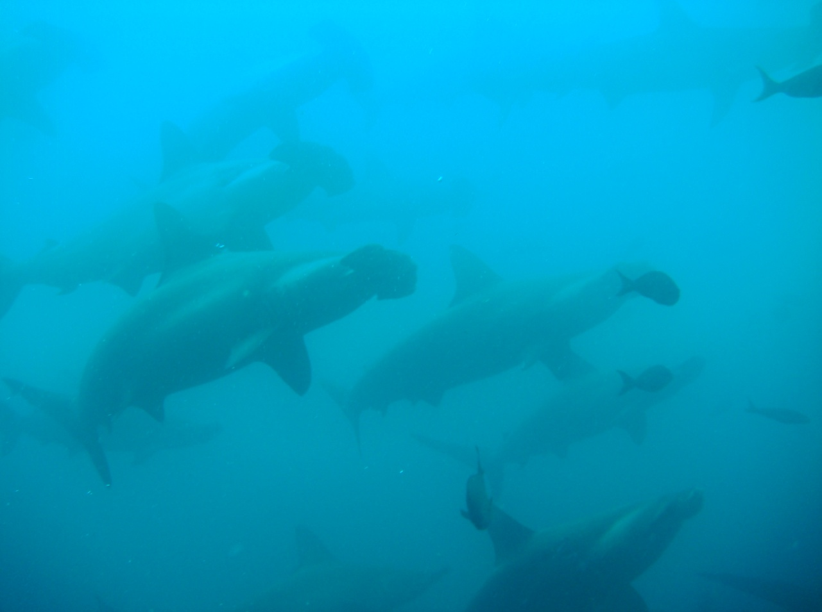
GORDON ROCKS
This tuff cone formation is a world famous dive site about one hour from our base. There are 4 dive sites in the area, but only two are for novices. The other two sites are for intermediates and experts because there can be strong currents and surge. The Gordon Rocks dive sites are mostly walls with a deep bottom. Blend in and blow few bubbles and you may be blessed with a hammerhead sighting! Hammerhead sharks are the main attraction of Gordon Rocks, where they often conglomerate in large schools. You won't be able to stop looking at this aquarium as you're likely to also see reef fish, large pelagic fish, golden rays, stingrays, eagle rays, turtles, morays.

SEYMUR
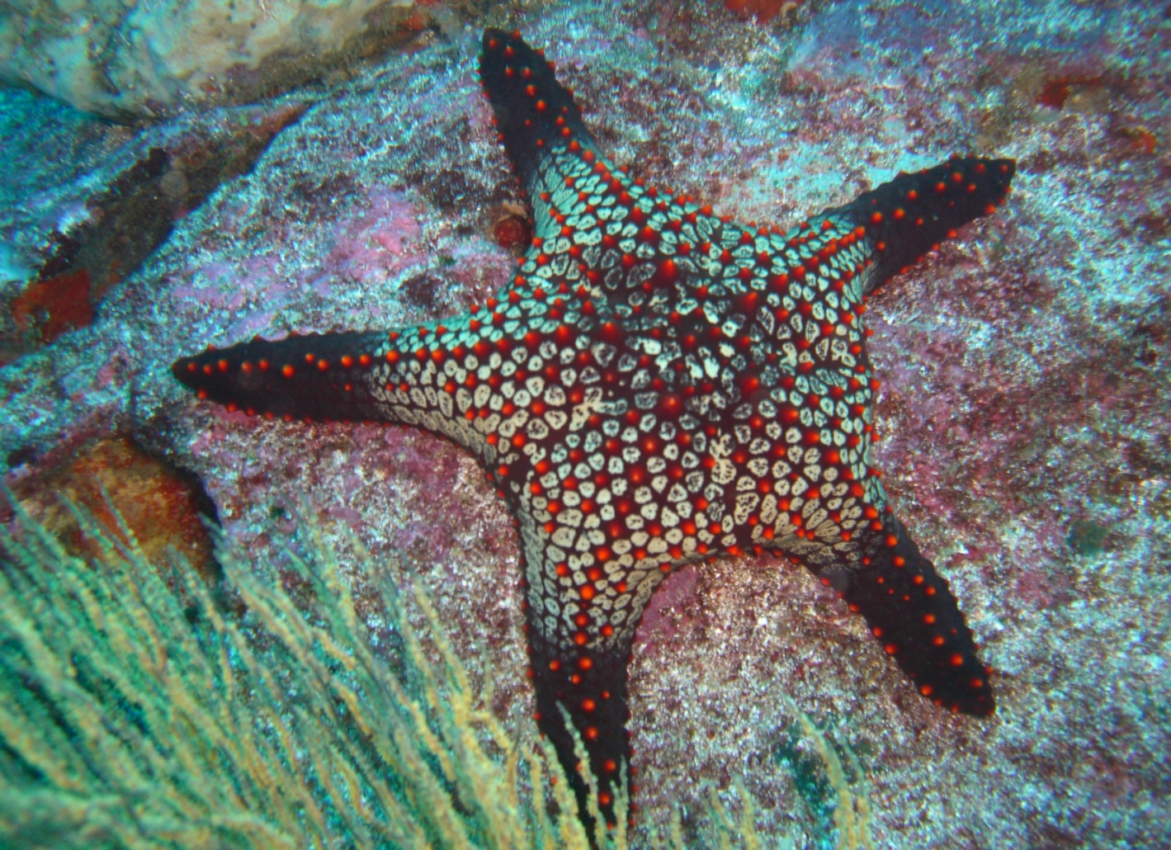
North Seymour is an uplifted island of lava flow about 90 minutes north of our dive base. There are 5 dive sites suitable for all levels of divers, although sometimes the currents can be strong. These sites have the most different species per square foot of sandy bottom. We can see cleaning behavior, a large garden eel colony, sea turtles, sea lions, fur seals, eagle rays, yellowtailed grunts, big-eyed jack, and frequently white tip reef sharks and hammerheads. Occasionally, Galapagos sharks can also be seen here.

COUSIN
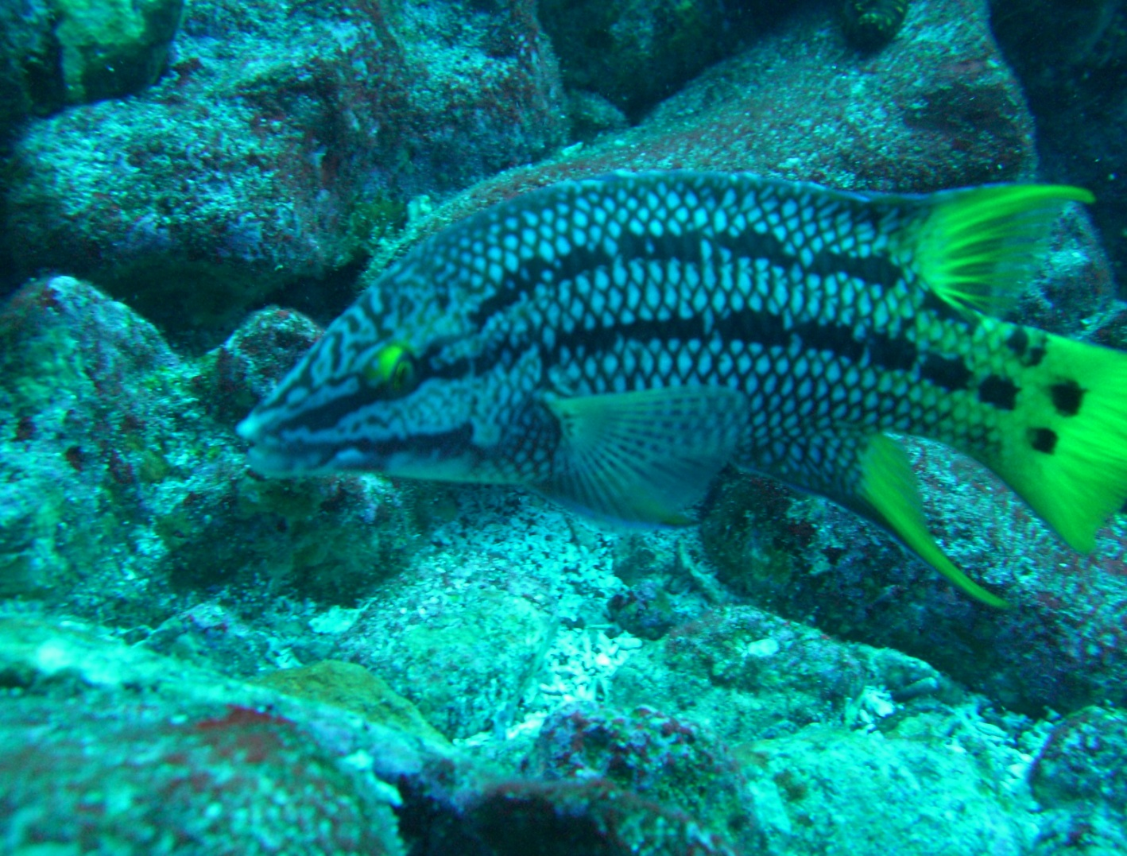
An islet with a wall dropping from the surface into the deepest depths, Cousins Rock is home to a big area of sloping rock plates known as a "Planchonal" about two hours from our base. There can be strong currents here that separate the productive and unproductive sides of the dive site. Cousins’ is full of spectacular endemic young black corals and other sightings may include frogfish, fur seals, sea turtles, sea horses, and usually, hammerhead sharks.

DAPHNE / MOSQUERA

Daphne is an isolated offshore tuff cone with vertical walls all around it about one hour from our dive base. The main dive site is a shelf of boulders at about 60 feet and the diving can be difficult depending on the currents and surge. We usually see many Galapagos sharks here, some schools of pelagic fish, and multicolored sponges on the rock wall. At Mosquera we can see cleaning behavior, a large garden eel colony, sea turtles, sea lions, fur seals, eagle rays, yellow-tailed grunts, big-eyed jack, and frequently white tip reef sharks and hammerheads. Occasionally, Galapagos sharks can also be seen here.

Days 5
Land visit to one of the following islands: Plazas and Punta Carrion, Seymur and Bachas, Bartolomé, Cerro Dragon and Venecia, Daphne Caleta Tortuga, Santa Fe and The Highlands of Santa Cruz Island.
We guarantee the excursions. Visiting place is subject to change according to availability.

Day 7: Monday 07.09
Galapagos-Guayaquil

Breakfast. Transfer to the airport, flight to Guayaquil then Lima.
B.

END OF SERVICES

7 days / 6 nights
--------------------------------------------------------------------------------------------------------------------
NET PRICE IN US$ PER PERSON

 | PAX
1
PAX
Tour based on single occupancy | 1113

Includes:

- Indicated Tours
- Indicated Accommodation
- Entrance fees
- Bilingual Guide and private transportation
- Mentioned meals (B: Breakfast, L: Lunch, BL: Box Lunch, D: Dinner)

Does not include:

- Personal Expenses and Tips
- Not mentioned meals
- Flight Lima-Guayaquil-Lima 359 USD (subject to change)
- Flight to Galapagos GYE-GPS-GYE 367 USD (subject to change)
- Ingala and National Park Galapagos fee 110 USD (subject to change)

Hotel Silberstein
Avenida Charles Darwin and Seymour
Puerto Ayora – Santa Cruz
Galápagos Islands - Ecuador

The Hotel Silberstein is located on Santa Cruz Island in the centre of Puerto Ayora and serves not only as a place to stay, but also as an information centre for tourists.
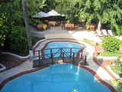
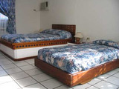
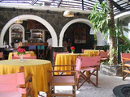

Location:
- located on Santa Cruz Island in the centre of Puerto Ayora
- 50 m to the sea
- 5 minutes walk to Charles Darwin Research Station

Rooms:
- 22 rooms, 11 matrimonial double rooms, 8 double rooms with twin beds and 3 triple rooms
- each are clean with private hot bath, ceiling fan, air condition and a view towards the swimming pool area

Services:
- Restaurant
- Breakfast inclusive
- Bar
- Fax, Internet access
- Laundry Service
- Diving Centre
- Bike Tours, Hikes



