COSTA RICA FAM TRIP
REKO TOURS PROGRAM

November 22nd, 2006
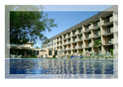
Welcome to Costa Rica. Arrival transfer to Best Western Irazu Hotel.
Located just 5 minutes away from downtown San Jose, and 15 minutes from the international airport, the Best Western Irazu has the ideal location to begin enjoying everything Costa Rica has to offer. With its large garden areas, outdoor swimming pool, 24 hour restaurant, 24 casino, La Cantina Bar and much more, you'll be within easy access to shopping malls, movies, restaurants and bars, yet away from the noise of the city. 24 hour restaurant and 24 hour casino. 325 rooms with coffee maker, safety deposit boxes, iron & ironing board, private bath with tub and shower, alarm clock/radio and much more.

November 23rd, 2006
Breakfast
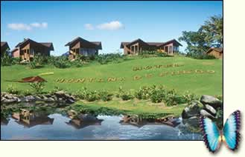
Today we will go to Arenal area. We will check in Montaña de Fuego Hotel. This hotel is located in La Fortuna, San Carlos; the hotel takes advantage of the natural beauty of the area and emerges as a peaceful oasis within a magnificent vegetation and diverse fauna. Its spacious and comfortable rooms offer you all the facilities to rest and relax. All the 50 bungalows have the spectacular view of the Arenal Volcano, and the view of the mountains. They have air conditioning, refrigerator, private bathroom with hot water, telephone, Direct T.V., and a private porch. After check in you’ll want a "one-of-a-kind experience", this tour is a must. You will be thrilled with the volcano’s magnificence. You may even witness an explosion of smoke and lava from the mighty Arenal. The exuberant vegetation in the surrounding areas will make you enjoy relaxing scenery and the refreshing cool air of the alpine region. Bring your bathing suit and towel to take a dip in the hot springs.
November 24th, 2006

Breakfast - Lunch
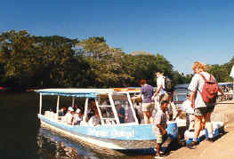
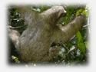
After breakfast we will start the Caño Negro Wildlife Refuge and the Rio Frío tour, both biological humid areas, considered being one of the richest in biological diversity in Costa Rica. Here you can find a great variety of resident and migratory birds plus three different species of monkeys, also iguanas, sloth’s, turtles and Caymans. All “Nature Lovers” will have a 4-hour floating safari through Tropical Rain Forest and pastures.
Overnight at Hotel Montaña de Fuego

November 25th, 2006
Breakfast
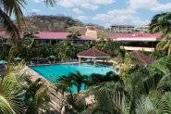
Today we will be transferred to Guanacaste famous for its dry climate and its long stretches of white, light brown and gray beaches, excellent resorts, great fishing and scuba diving among the many activities and sightseeings available. Overnight at Hotel Flamingo Beach. Playa Flamingo is one of Costa Rica’s must luxuriant beaches, and this deluxe, modern resort features 91 large, air conditioned rooms and suites literally steps away the crystal blue waters of the Pacific Ocean. The Flamingo Beach Resort is perfect for anglers on sport fishing charters and members of boating expeditions who would like to spend some time in Costa Rica.

November 26th, 2006
Breakfast
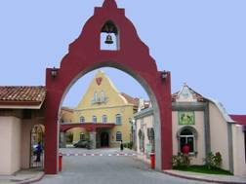
Transfer back to San Jose. Lodging at Hotel Casa Conde. Hotel Casa Conde is located 5 minutes from San Jose and 30 minutes from International Airport. 110 furnished two-bedroom luxury apartments. Equipped with dining room, sofa bed, TV with DCD player, air conditioning. 24 hour laundry service and a computer center equipped with access, fax, photocopy machine and scanner.

November 27th, 2006
Breakfast
Transfer to the airport 3 hours prior departure.

PROGRAM SPECIFICATIONS
PROGRAM INCLUDED

1 NIGHT AT BW IRAZU ***
2 NIGHTS AT MONTAÑA DE FUEGO ****
1NIGHT AT FLAMINGO BEACH ****
1 NIGHT AT CASA CONDE ****

MEALS:
DAILY BREAKFAST
LUNCH: DAY 24TH

ENTRANCE FEE: ARENAL VOLCANO, ECOTERMALES HOT SPRINGS

OTHERS:
BILINGUAL GUIDE, DRIVER AND TRANSPORTATION DURING ALL PROGRAM, 2 TC FREE OF CHARGE IN DBL OCCUPANCY

NOT INCLUDED
MEALS NO SPECIFY ABOVE // TOURS NO MENTIONED ABOVE // DEPARTURE TAX : $26.00 PP // GUIDE AND DRIVER TIPS.

